Data Structure and Algorithms 2:
Unit 5:
Algorithm Properties
5.1 Greedy algorithms
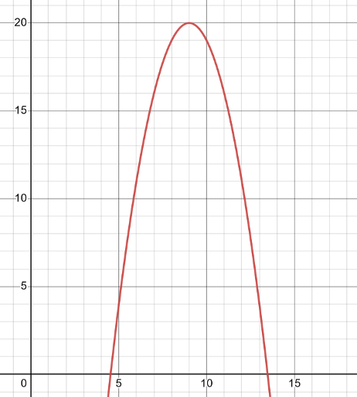
Greedy algorithms are a type of algorithms that choose the “optimal” strategy in each step. If we remember that an algorithm is a finite sequence of steps, from DSA-1, we can see that, in some algorithms, in each step there could be an optimal choice. We’ll see an example later on.
The idea with greedy algorithms is that by selecting the optimal choice at each step, i.e. thinking “locally”, considering only the next step and not the big picture (not “globally”), the algorithm eventually will reach a solution, and in some cases it will be the best solution globally.
That means that greedy algorithms will always take the optimal choice at every step without considering any other factors. This might or might not find the optimal global solution, as we will see in the mathematical example below. Of course, a very important point in greedy algorithms is the choice of that “optimal” step, and we will see some examples of this as well.
Example: maximum point of a function
If we want to reach the maximum point of a function, we could propose the following greedy algorithm:
From any point in the x axis, if the slope is positive (slope defined as 𝑚=Δ𝑦Δ𝑥), the optimal choice to find the maximum is increasing the “x” value, i.e., keep going to the “right”.
Alternatively, if the slope is negative, move towards the “left”, i.e., decrease on the x axis.
If there is a change of slope in the following way: positive to 0, negative to 0 or positive to negative, the point where the slope changes or is 0 is the maximum point of the function.
Will this work? Well, with a function like this one below, without a problem. It will also find the global maximum.
But what happens if the function is like this one?
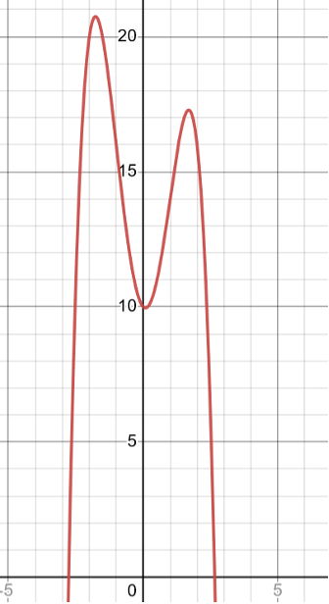
In this case, it depends on the starting point of our algorithm. The greedy algorithm will give a maximum point, but it won’t necessarily be the global maximum – it could be the local maximum.
5.2 Las Vegas algorithms
Las Vegas algorithms are a type of probabilistic algorithms.
Probabilistic algorithms are those in where the algorithm makes a random choice at some point. They might also be called “randomised algorithms”.
For Las Vegas algorithms particularly, this type of randomised algorithms will always give the correct solution OR will indicate that it failed to reach any result.

So we have two important pieces in this definition:
- It needs to add randomisation
- It needs to either end correctly or inform of the failure
As you can realise, the completion criterion can bring to two different scenarios, which are:
The fact that it might need to end giving an correct result makes the time-complexity of the algorithm unknown. It might be correct the first time or it might take a long time ti finish, escalating the time-complexity greatly, and we have no way of knowing it, since randomness is a key part of the algorithm. So in this instance where a Las Vegas algorithm runs until it ends correctly the time to finish is not bound. You’ll be able to see this in the tasks proposed.
On the other hand, the fact that it might not give a result and just indicate that it failed means that we might need to have an indeterminate number of runs before it actually gives a correct solution.
5.3 Monte Carlo algorithms
Monte Carlo algorithms are also a type of probabilistic algorithms, meaning randomness is a key factor in this type of algorithms. They usually are thought in contraposition to Las Vegas, as a Monte Carlo-type algorithm is sure to give an answer after a finite amount of time, but it might not be a correct answer.
The main idea with a Monte Carlo algorithm is to assume that there will always be a small probability of error; so these algorithms will always give a solution, but there will be a probability where this solution is not correct. In some problems, this small probability of error can diminish the more time it passes, or the more computation the algorithm does, but that’s not a given.
Transform Las Vegas into Monte Carlo
We can always transform a Las Vegas type algorithm into a Monte Carlo type algorithm by making it time-bound.

